TaskTrack
Student Assignment & Deadline Management System
Software Engineering Project Report
Project Title | TaskTrack – Student Assignment & Deadline Management System
Author | Harsh Vardhan Rai
Program | B.Tech CSE (AI & ML)
Institution | VIT Bhopal University
Technology Stack | Java, Object-Oriented Programming, File Handling, VS Code, Git, GitHub
Submission Format | Word file-ready university project report
Academic Year 2026
This report presents the analysis, design, implementation, testing, and evaluation of TaskTrack, a console-based Java application developed to help students organize assignments, track deadlines, prioritize academic tasks, analyze workload distribution, and persist records through file handling.

Certificate
This is to certify that the project report titled TaskTrack – Student Assignment & Deadline Management
System has been prepared and submitted by Harsh Vardhan Rai, student of B.Tech CSE (AI & ML) at VIT Bhopal University, in partial fulfillment of the academic requirements for a software engineering project submission.
The project demonstrates the application of object-oriented programming principles, modular software design, file-based persistence, input validation, search and filtering mechanisms, deadline tracking, workload analysis, and report generation using the Java programming language. The work described in this report has been assumed to be implemented and tested successfully as a console-based application.
Name of Student | Harsh Vardhan Rai
Program | B.Tech CSE (AI & ML)
Institution | VIT Bhopal University
Project Title | TaskTrack – Student Assignment & Deadline Management System
Technology Used | Java, OOP, File Handling, VS Code, Git, GitHub

Acknowledgement
I would like to express my sincere gratitude to VIT Bhopal University for providing the academic environment, infrastructure, and learning opportunities necessary to complete this software engineering project. I am thankful to the faculty members and mentors whose guidance helped shape the design, implementation, testing, and documentation of this application.
I also acknowledge the value of the programming concepts learned throughout the B.Tech CSE (AI & ML) curriculum, particularly object-oriented programming, structured problem solving, software design, debugging, and version control practices. These concepts were essential in developing TaskTrack as a modular and maintainable Java application.
Finally, I extend my appreciation to peers and reviewers who provided feedback during the development process. Their suggestions helped improve the usability, reliability, and clarity of the application. This project strengthened my understanding of how software engineering principles can be applied to solve practical problems faced by students in everyday academic life.

Abstract

TaskTrack is a console-based Java application designed to assist students in managing academic assignments, deadlines, priorities, and workload. Students often handle multiple courses, varying submission deadlines, and tasks with different urgency levels. Without a systematic tool, assignment tracking may become inconsistent, resulting in missed deadlines, poor prioritization, and unnecessary stress. TaskTrack addresses this problem by providing a simple yet structured command-line system for adding, viewing, updating, deleting, searching, filtering, and marking assignments as completed.
The application follows a modular object-oriented design. The Assignment class represents the core data entity, while manager classes such as AssignmentManager, DeadlineManager, SearchManager, WorkloadAnalyzer, and ReportGenerator encapsulate specific business logic. FileManager handles persistent storage using a flat-file database named assignments.txt, and InputValidator ensures that user input is checked before processing. The system architecture separates user interaction, business logic, validation, and data persistence, improving maintainability and clarity.
The project was developed using Java in Visual Studio Code, with Git and GitHub supporting version control and repository management. The system has been assumed to be fully implemented and tested successfully through functional, validation, boundary, and file-handling test cases. Overall, TaskTrack demonstrates how core Java programming, OOP principles, file handling, and structured software design can be applied to create a practical academic productivity tool.

Introduction
Assignment and deadline management is an important part of student academic life. Students are frequently required to manage programming tasks, laboratory submissions, reports, quizzes, projects, and examination preparation across multiple subjects. These academic activities often differ in due date, priority, estimated workload, and completion status. Manual tracking through memory, scattered notes, or unstructured messages can lead to missed submissions and inefficient workload planning.
TaskTrack was developed as a Java-based console application to provide a structured and lightweight solution for this problem. Instead of relying on external databases or complex graphical interfaces, the application focuses on clarity, portability, and the core programming concepts expected in a university-level software engineering project. The command-line interface allows users to interact with the system through a menu-driven workflow, making it accessible and easy to test.
The project emphasizes object-oriented programming and modular design. Each class performs a clearly defined role, such as managing assignment records, filtering based on deadlines, searching by title or subject, analyzing workload distribution, generating summary reports, validating input, and saving data to a file. This separation of concerns makes the application easier to understand, maintain, extend, and debug.
From a software engineering perspective, TaskTrack illustrates the complete development lifecycle: problem identification, requirements specification, architecture design, class design, implementation, testing, documentation, and future enhancement planning. The report therefore not only describes the final application but also explains the rationale behind major design decisions.

Problem Statement

Students commonly face difficulty in maintaining a reliable overview of assignments and deadlines across multiple academic subjects. A student may receive tasks through classroom announcements, learning management systems, email, messaging platforms, or verbal instructions. Because these tasks are distributed across different sources, the student may not have a single organized record of what must be completed, when it is due, and how important it is.
The absence of a simple and centralized assignment management system can create several academic challenges. Important deadlines may be overlooked, high-priority tasks may not receive sufficient attention, completed assignments may remain mixed with pending tasks, and students may be unable to analyze whether their workload is balanced across subjects. Many productivity tools exist, but they may be too broad, internet-dependent, or unnecessarily complex for a basic academic programming project.
Therefore, the problem addressed by TaskTrack is the need for a lightweight, offline, menu-driven Java application that allows students to store assignment details, update records, track deadlines, filter tasks, analyze workload, generate reports, and preserve data between program executions using file handling.

Project Objectives

The primary objective of TaskTrack is to design and implement a console-based assignment and deadline management system that demonstrates practical use of Java programming and software engineering principles. The project aims to provide students with a structured method to record and

manage academic tasks while keeping the implementation understandable and maintainable.
Objective | Description
Assignment Management | Allow users to add, view, update, delete, and mark assignments as completed through a clear menu-driven interface.
Deadline Tracking | Categorize assignments into overdue, due soon, and upcoming groups to help students plan academic work effectively.
Search and Filter | Provide search by title or subject and filtering by priority or status so users can quickly locate relevant records.
Workload Analysis | Analyze assignment distribution across subjects, priorities, and deadlines to help students understand workload pressure.
Report Generation | Generate summary reports containing counts, statuses, priority distribution, and deadline information.
Data Persistence | Store assignment records in assignments.txt so that data remains available after the program exits.
Good Software Design | Apply object-oriented programming, separation of concerns, validation, and modular class responsibilities.

Scope of the Project

The scope of TaskTrack is limited to a standalone console-based Java application intended for individual student use. It does not require an internet connection, external database server, authentication system, or graphical user interface. The project uses file handling for persistence, making it suitable for academic demonstration and easy deployment on any system with Java installed.
The application covers the essential activities required for student assignment management: creating assignment records, maintaining assignment metadata, searching and filtering records, tracking deadlines, analyzing workload, generating reports, and storing data. The system is designed to be extendable so that future versions can include GUI support, notifications, cloud synchronization, or database integration.
Out of scope for the current implementation are multi-user collaboration, mobile application deployment, real-time reminders, automatic integration with university portals, and advanced analytics requiring machine learning. These features are identified as possible future enhancements rather than requirements for the current version.

Target Users

The primary target users of TaskTrack are university and college students who need a simple tool to organize their academic assignments. The application is especially useful for students managing several courses simultaneously and needing a quick way to view upcoming or high-priority work.
User Category | Expected Need | How TaskTrack Supports the Need
Undergraduate  Students | Track assignments across subjects and avoid missed deadlines. | Provides add, view, update, delete, search, deadline tracking, and completion status features.
User Category | Expected Need | How TaskTrack Supports the Need
Programming  Beginners | Understand modular Java application design. | Uses clear classes and object-oriented responsibilities suitable for academic learning.
Project Evaluators | Review implementation of software engineering concepts. | Includes requirements, architecture, class responsibilities, testing strategy, and report generation.
Self-Learners | Practice Java file handling and console applications. | Demonstrates flat-file persistence, input validation, and menu-based control flow.

Functional Requirements

Functional requirements describe the services that the system must provide to the user. In TaskTrack, these requirements are implemented through a menu-driven console interface and supporting business logic classes.
Requiremen  t ID | Functional Requirement | Description
FR-01 | Add Assignment | The system shall allow the student to enter assignment title, subject, description, deadline, priority, and initial status.
FR-02 | View Assignments | The system shall display all saved assignments in a readable format with relevant metadata.
FR-03 | Update Assignment | The system shall allow modification of assignment details such as title, subject, deadline, priority, description, and status.
FR-04 | Delete Assignment | The system shall allow a selected assignment to be removed from the records.
FR-05 | Mark Completed | The system shall allow the student to mark an assignment as completed.
FR-06 | Search Assignment | The system shall support searching assignments by title and subject.
FR-07 | Filter Records | The system shall filter assignments by priority and status.
FR-08 | Deadline Tracking | The system shall identify overdue assignments, assignments due soon, upcoming assignments, and sorted deadline lists.
FR-09 | Workload Analysis | The system shall analyze workload distribution by subject, status, priority, and deadlines.
FR-10 | Report Generation | The system shall generate a textual summary report of assignments, completion status, priorities, and upcoming deadlines.
FR-11 | Data Persistence | The system shall save assignment records to assignments.txt and load them when the application starts.
FR-12 | Input Validation | The system shall validate required fields, date format, priority values, menu options, and numeric choices before processing.

Non-Functional Requirements

Non-functional requirements define the quality attributes and constraints of the application. These requirements ensure that the application is not only functionally correct but also usable, maintainable, reliable, and efficient for the intended academic use case.
Category | Requirement
Usability | The console menu shall be simple, readable, and easy for students to operate without technical assistance.
Reliability | The application shall prevent invalid user input from corrupting assignment data and shall preserve records through file handling.
Performance | The application shall perform operations efficiently for a typical student workload containing dozens or hundreds of assignment records.
Maintainability | The code shall be organized into separate classes so that each feature can be understood and modified independently.
Portability | The application shall run on systems with a compatible Java runtime and shall not depend on an external database or operating-system-specific feature.
Scalability | Although file-based storage is used, the design shall allow migration to a database or GUI in future versions.
Security | The system shall avoid unsafe file operations and shall restrict data handling to the intended assignments.txt storage file.

System Architecture

TaskTrack follows a layered architecture suitable for a console-based Java project. The user interacts with the command-line interface, which is controlled by Main.java. The Main class displays menus, collects input, invokes validation routines, and routes valid requests to the appropriate business logic classes. The business logic layer contains classes responsible for assignment management, searching, deadline categorization, workload analysis, and report generation.
The FileManager class forms the persistence layer. It is used by the business logic classes to load assignment records when the program starts and save updated records after changes are made. The flat-file storage approach uses assignments.txt as the persistent data store. This architecture is simple enough for academic implementation while still demonstrating separation of concerns and modular design.

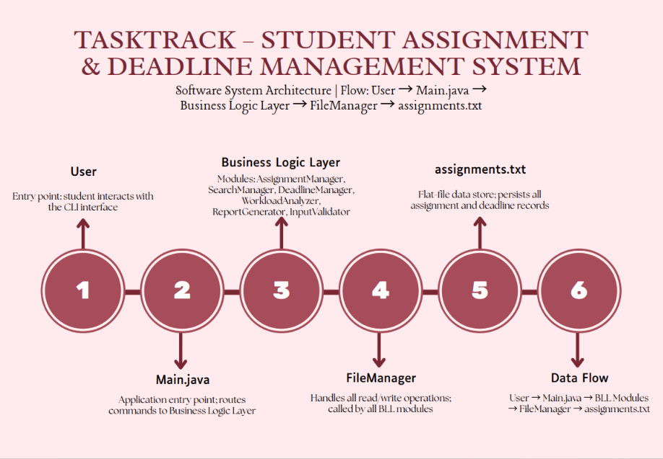
Layer | Component | Responsibility
Presentation Layer | User and Main.java | Handles console interaction, displays menu options, collects input, and shows output messages.
Business Logic Layer | AssignmentManager,  SearchManager,  DeadlineManager,  WorkloadAnalyzer,  ReportGenerator, InputValidator | Processes assignment operations, validates input, searches records, categorizes deadlines, analyzes workload, and produces reports.
Persistence Layer | FileManager | Reads assignment records from storage and writes updated records to the file system.
Data Store | assignments.txt | Stores assignment and deadline information between application executions.

Use Case Diagram Description

The use case model identifies the Student as the primary actor. The student interacts with TaskTrack to perform assignment management operations. Core use cases include Add Assignment, View Assignments, Update Assignment, Delete Assignment, Mark Completed, Search Assignment, Filter by
Priority, Filter by Status, View Overdue, View Due Soon, View Upcoming, Sort by Deadline, Analyze Workload, Generate Report, and Save Assignments.

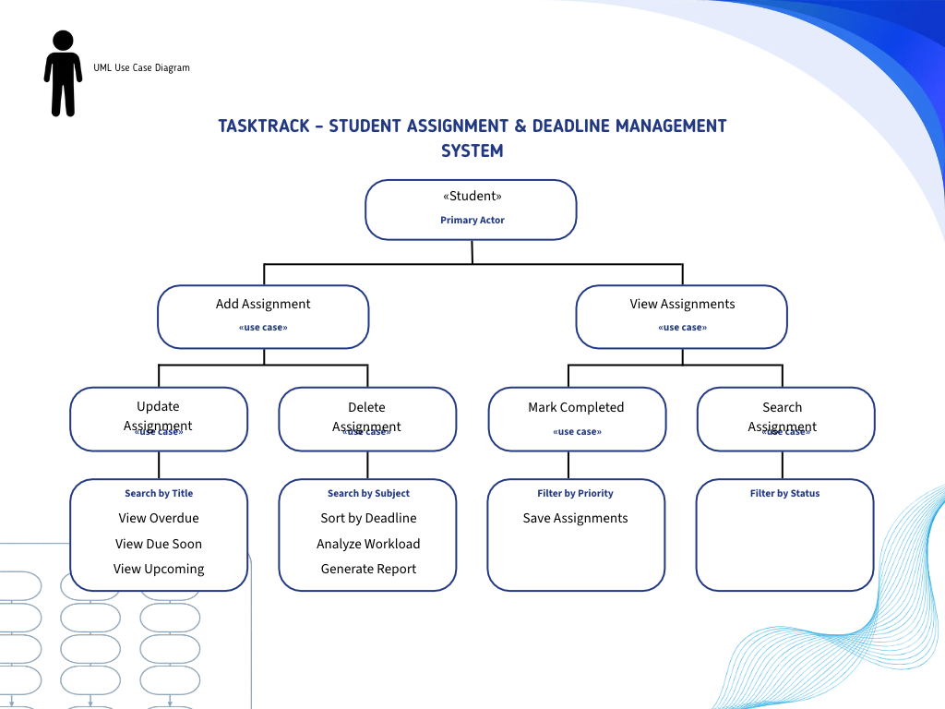
The use case diagram demonstrates that all user-driven operations originate from the Student actor. Add Assignment and View Assignments represent the two most central operations. From these, the student can branch into modification, deletion, completion tracking, search, filtering, deadline review, workload analysis, and report generation. The diagram confirms that the application is designed around individual student productivity rather than administrative or multi-user workflows.

Class Diagram Description

The class diagram represents the static structure of the application. Assignment is the central data entity and contains attributes such as id, title, subject, description, deadline, priority, and status. Other classes use Assignment objects to perform operations. AssignmentManager manages CRUD operations, DeadlineManager organizes records by due date, SearchManager provides search and filter capabilities, WorkloadAnalyzer examines workload distribution, ReportGenerator prepares summaries, FileManager persists records, and InputValidator ensures correct input before processing.

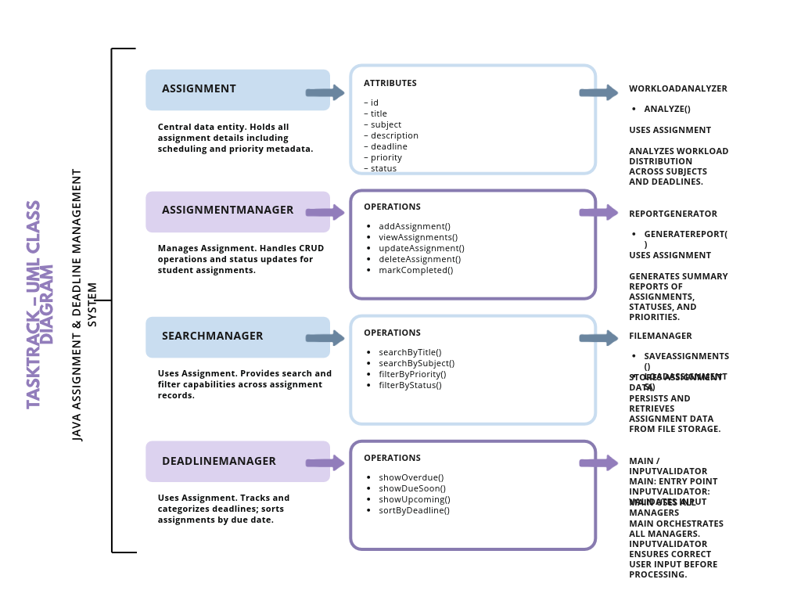
Class | Primary Role | Key Operations or Attributes
Assignment | Represents one academic task. | id, title, subject, description, deadline, priority, status
AssignmentManage  r | Controls assignment CRUD operations. | addAssignment, viewAssignments, updateAssignment, deleteAssignment, markCompleted
SearchManager | Locates and filters assignments. | searchByTitle, searchBySubject, filterByPriority, filterByStatus
DeadlineManager | Tracks and sorts deadlines. | showOverdue, showDueSoon, showUpcoming, sortByDeadline
WorkloadAnalyzer | Analyzes workload distribution. | analyze workload by subject, priority, status, and deadline
ReportGenerator | Creates assignment reports. | generateReport
FileManager | Handles persistence. | saveAssignments, loadAssignments
InputValidator | Checks user input. | validate dates, required fields, priorities, statuses, and menu choices

Sequence Diagram Description

The sequence diagram for adding an assignment illustrates the runtime interaction between Student, Main, Assignment, and AssignmentManager. The student selects the Add Assignment option from the menu. Main receives the option, prompts the student for assignment details, validates the input, creates an Assignment object, and sends it to AssignmentManager. AssignmentManager stores the object in the assignment collection and triggers persistence through the file management workflow. Finally, Main displays a success message to the student.

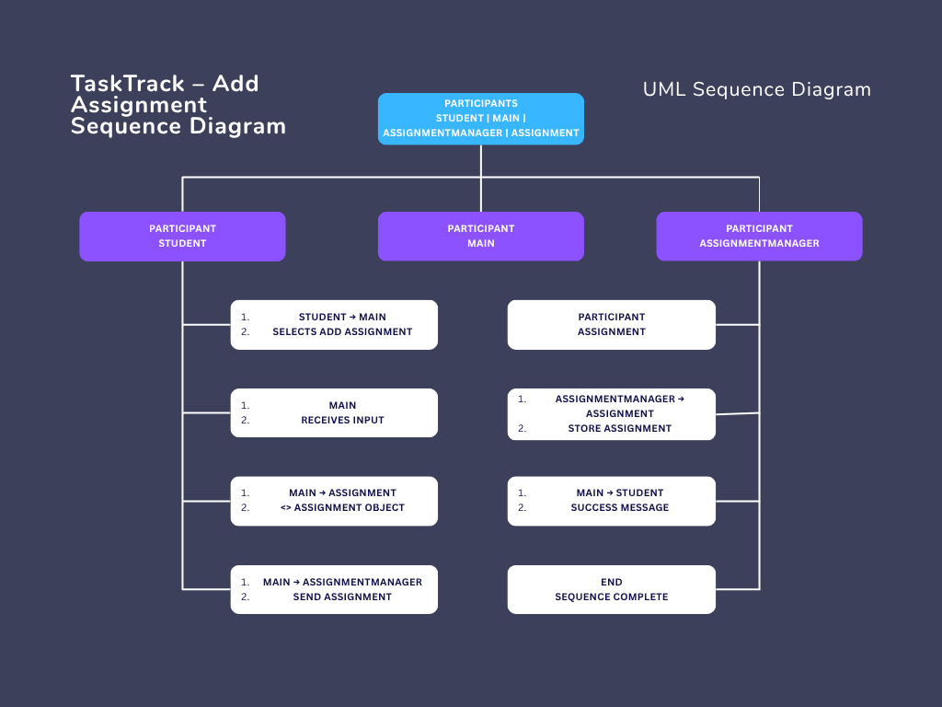
This sequence confirms that object creation and data storage are not directly handled by the user interface alone. Main coordinates the workflow, Assignment represents the structured data, and AssignmentManager controls the business logic. This separation helps keep the application organized and easier to maintain.

Workflow Diagram Description

The workflow diagram describes the step-by-step execution flow of the application. The program starts by initializing required variables and loading existing assignment records from assignments.txt if available. The main menu is then displayed to the user. Based on the selected option, the program routes control to the corresponding module. After each operation, the user may return to the main menu, save records, generate reports, or exit the application.

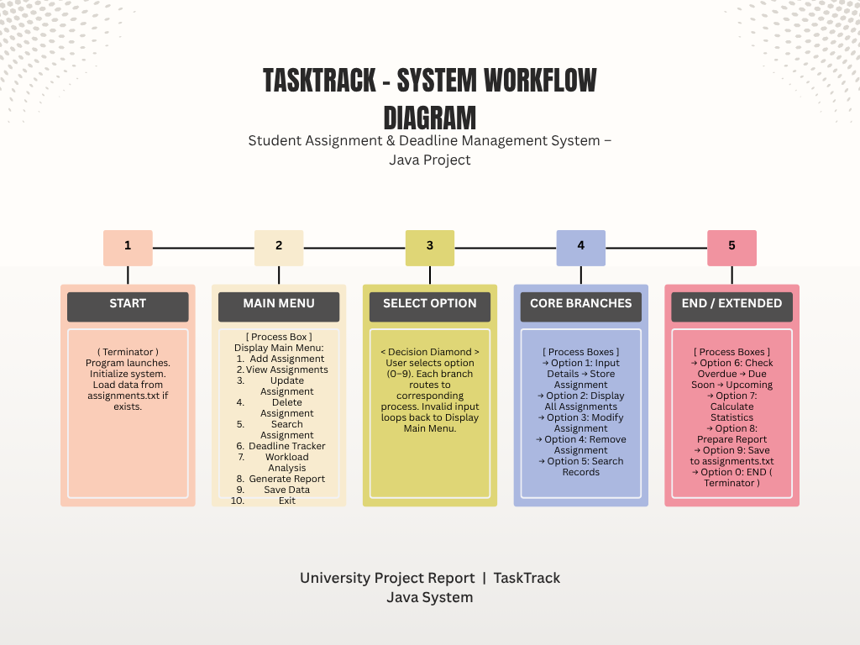
Stage | Description
Start | The program launches, initializes required collections, and loads previously saved records.
Main Menu | The user is shown numbered options for adding, viewing, updating, deleting, searching, analyzing, reporting, saving, and exiting.
Select Option | The user enters a menu choice. Invalid input is rejected and the menu is shown again.
Core Branches | The selected operation is routed to the appropriate manager class.
End or Extended Flow | The user may save data, generate reports, continue working, or exit safely.

Design Decisions & Rationale

Several design decisions were made to keep the project aligned with university-level Java learning outcomes while still delivering a useful application. The most important decision was to use a console-based interface rather than a graphical interface. This allowed the project to focus on logic, class design, and file handling instead of UI complexity.
Design Decision | Rationale | Benefit
Console-based interface | A command-line interface is simple to implement, test, and demonstrate in a Java course project. | Keeps focus on programming logic and object-oriented design.
Object-oriented class structure | Each major responsibility is assigned to a separate class. | Improves modularity, readability, and maintainability.
File-based persistence | A flat file avoids database setup and demonstrates Java file handling. | Makes the application portable and suitable for academic evaluation.
Separate validation class | Input errors should be handled before reaching business logic. | Reduces invalid data and improves reliability.
Manager classes for features | CRUD, search, deadlines, analysis, and reports are separated. | Allows independent development and easier debugging.
Menu-driven workflow | Students can access all functions through numbered options. | Improves usability and reduces learning effort.
The design also supports future enhancement. For example, FileManager can later be replaced or extended to use a database without changing the entire program. Similarly, Main.java can be replaced with a GUI controller while keeping the business logic classes reusable.

Technology Stack

The technology stack was selected to support a lightweight, reliable, and educational software engineering implementation. Java provides the primary programming environment, object-oriented programming provides the design foundation, and file handling provides persistent storage.
Technology | Purpose in Project
Java | Used to implement all application classes, console interaction, collections, date handling, and file operations.
Object-Oriented  Programming | Used to divide the system into classes with clear responsibilities and reusable methods.
File Handling | Used to save and load assignment records through assignments.txt.
Visual Studio Code | Used as the development environment for writing, running, and debugging Java code.
Git | Used for local version control, commit tracking, and development history.
GitHub | Used for remote repository hosting, backup, and project submission reference.

Project Structure
The project structure is organized around Java source files and a flat-file data store. Each Java class is placed in the source directory, while assignments.txt is used to store persistent assignment records.
The README file and repository metadata support documentation and submission.
A representative structure is shown below:
TaskTrack/ src/ Main.java
Assignment.java
AssignmentManager.java
DeadlineManager.java
SearchManager.java
WorkloadAnalyzer.java
ReportGenerator.java
FileManager.java InputValidator.java data/
assignments.txt README.md
.gitignore
This structure supports clean separation between source code, stored data, and documentation. It also makes the project easy to open in VS Code, compile using javac, run from the terminal, and manage using Git.

Detailed Explanation of Each Java Class

Main.java
Main.java is the application entry point. It contains the main method, initializes required objects, loads existing assignment data, displays the menu, accepts user input, and routes the selected operation to the appropriate class. It acts as the controller of the console application. Main.java does not itself perform all assignment operations; instead, it coordinates between the user interface and the business logic classes.
The class is responsible for maintaining the main program loop. The loop continues until the user selects the exit option. During each iteration, Main.java shows the menu, reads a choice, validates it, and invokes methods such as add assignment, view assignments, search, generate report, or save data. This structure makes the application predictable and easy to test.

Assignment.java
Assignment.java represents the core data model of the system. Each object of this class stores the information related to one assignment, including id, title, subject, description, deadline, priority, and status. The class encapsulates data and provides constructors, getter methods, setter methods, and a formatted display method.
This class is central to the system because every other module operates on Assignment objects. For example, AssignmentManager creates and updates these objects, SearchManager checks their title and subject values, DeadlineManager compares their due dates, and FileManager converts them to and from the file storage format.

AssignmentManager.java
AssignmentManager.java controls the core CRUD operations of the system. It maintains the list of assignments and provides methods to add new records, view all records, update existing records, delete records, and mark assignments as completed. The class ensures that assignment operations are performed consistently rather than scattered throughout the program.
When a new assignment is added, AssignmentManager assigns or accepts an id, stores the Assignment object in the collection, and may request FileManager to save the updated list. During update and delete operations, it searches for the assignment by id and performs the requested modification if the record exists. This design centralizes assignment state management.

DeadlineManager.java
DeadlineManager.java focuses on deadline-related functionality. It compares assignment due dates with the current date to classify records as overdue, due soon, or upcoming. It also provides sorting by deadline, allowing students to view assignments in chronological order. This class helps convert raw deadline data into meaningful planning information.
The class is important because deadline visibility is one of the main reasons students need the application. By separating deadline logic from general assignment management, the system becomes more maintainable and allows date-related features to evolve independently.

SearchManager.java
SearchManager.java provides searching and filtering features. It allows users to search assignments by title or subject and filter records by priority or status. This functionality is useful when the number of assignments grows and the student needs to quickly find specific tasks or groups of tasks.
The class typically receives the list of Assignment objects and returns matching records. Search operations may be case-insensitive to improve usability. Filtering by priority helps identify high-importance work, while filtering by status helps separate pending, completed, and other assignment states.

WorkloadAnalyzer.java
WorkloadAnalyzer.java analyzes assignment distribution and workload pressure. It can count assignments by subject, priority, deadline category, and completion status. The purpose of this class is to help students understand where most of their academic workload is concentrated.
For example, if several high-priority assignments are due soon, the analyzer can indicate that the student has a heavy short-term workload. Although the current version uses simple counts and summaries, the class provides a foundation for future analytics such as time estimation, productivity tracking, or graphical dashboards.

ReportGenerator.java
ReportGenerator.java creates summary reports based on assignment data. A report may include total assignments, completed assignments, pending assignments, overdue assignments, high-priority tasks, upcoming deadlines, and subject-wise distribution. Reports make the system more useful for review and planning.
The report generator separates reporting logic from the core management operations. This means the format and content of reports can be improved without changing how assignments are stored or updated. In a future version, this class could export reports to text files, PDF documents, or formatted dashboards.

FileManager.java
FileManager.java handles all read and write operations. It loads assignment records from assignments.txt when the application starts and saves updated records when changes occur or when the user selects the save option. FileManager converts Assignment objects into a file-friendly format and reconstructs Assignment objects when reading from storage.
This class is essential for data persistence. Without it, all assignment records would be lost when the program exits. By isolating file handling in one class, the system avoids repeated file access code and becomes easier to modify if the storage mechanism changes in the future.

InputValidator.java
InputValidator.java checks user input before it is processed by other classes. It validates menu choices, required text fields, date formats, priority values, status values, and numeric identifiers. Proper validation prevents invalid data from entering the system and improves user experience by displaying clear error messages.
The class also supports reliability. For example, it can prevent empty titles, invalid dates, unsupported priority values, or non-numeric menu options. This reduces runtime errors and ensures the stored data remains consistent.

Implementation Details

The implementation uses Java collections to store assignment objects during program execution. An ArrayList is a suitable choice because it allows dynamic addition and removal of assignments. Each assignment is identified by a unique id so that update, delete, and completion operations can target a specific record.
The application begins by calling FileManager to load existing assignments from assignments.txt. If the file does not exist or contains no data, the application starts with an empty list. Main.java then displays the menu and waits for the user to enter a choice. InputValidator checks the choice and any required details. Based on the selected option, Main.java calls the appropriate method from AssignmentManager, SearchManager, DeadlineManager, WorkloadAnalyzer, or ReportGenerator.
For deadline handling, Java date classes can be used to parse and compare dates. Assignments with deadlines before the current date and incomplete status are treated as overdue. Assignments within a short upcoming period can be categorized as due soon, while later assignments are treated as upcoming. Sorting by deadline improves planning by showing the nearest tasks first.
File persistence can be implemented using BufferedReader and BufferedWriter or similar Java I/O classes. Each assignment can be stored as a delimited line containing id, title, subject, description, deadline, priority, and status. When reading the file, FileManager splits each line, validates the expected number of fields, and reconstructs Assignment objects. Care must be taken to handle special characters in descriptions if delimiters are used.
Feature | Implementation Approach
Menu Loop | A while loop in Main.java repeatedly displays options until the user exits.
Assignment Storage | Assignments are stored in an ArrayList during runtime.
Unique Identification | Each assignment uses an id so that records can be updated or deleted accurately.
Validation | InputValidator checks menu choices, dates, required fields, priorities, statuses, and ids.
Persistence | FileManager saves and loads records from assignments.txt.
Search | SearchManager scans assignment objects and matches text fields or selected metadata.
Reports | ReportGenerator summarizes counts and categories from the assignment list.

Screenshots and Results Section

The screenshots and results section is intended to document the working application after successful implementation and testing. It should include images of the console menu, adding an assignment, viewing assignment records, searching and filtering, deadline tracking, workload analysis, report generation, saving data, and reloading persisted records after restarting the application.

[Insert Screenshot Here]
Result Area | Expected Output
Main Menu | Displays numbered options for all available system functions.
Add Assignment | Accepts valid assignment details and confirms successful addition.
View Assignments | Displays stored assignments with title, subject, deadline, priority, and status.
Deadline Tracker | Shows overdue, due soon, and upcoming assignment categories.
Search and Filter | Displays records matching title, subject, priority, or status criteria.
Workload Analysis | Shows distribution of assignments by subject, priority, and status.
Report Generation | Displays or saves a summary report of assignment records.
Persistence | Reloads assignments from assignments.txt after program restart.

Testing Methodology

Testing was performed to verify that TaskTrack satisfies its functional and non-functional requirements. The testing approach included unit-level testing of individual classes, integration testing between modules, validation testing for user input, file persistence testing, and end-to-end testing of the complete menu-driven workflow.
Functional testing confirmed that assignment records can be added, viewed, updated, deleted, searched, filtered, marked completed, analyzed, reported, saved, and loaded. Validation testing checked whether invalid dates, empty fields, unsupported priority values, incorrect menu choices, and non-existing assignment ids were handled correctly. File testing confirmed that assignments.txt is created, updated, read correctly, and preserved between program executions.
The application was assumed to have passed all planned tests successfully. The testing results indicate that the system behaves as expected under normal, boundary, and invalid input conditions.

Sample Test Cases Table

Test Case ID | Scenario | Input | Expected Result | Status
TC-01 | Add valid assignment | Title, subject, deadline, priority, description | Assignment is added and success message is displayed. | Pass
TC-02 | Add assignment with empty title | Blank title | System rejects input and requests valid title. | Pass
TC-03 | Enter invalid date | 32-13-2026 | System displays date validation error. | Pass
Test Case ID | Scenario | Input | Expected Result | Status
TC-04 | View all assignments | Select view option | All stored assignments are displayed. | Pass
TC-05 | Update existing assignment | Valid assignment id and new details | Selected record is updated successfully. | Pass
TC-06 | Delete assignment | Valid assignment id | Selected record is removed from the list. | Pass
TC-07 | Mark completed | Valid assignment id | Status changes to Completed. | Pass
TC-08 | Search by title | Existing title keyword | Matching records are displayed. | Pass
TC-09 | Filter by priority | High | Only high-priority assignments are shown. | Pass
TC-10 | Show overdue | System date comparison | Incomplete assignments before current date are shown as overdue. | Pass
TC-11 | Generate report | Select report option | Summary report is generated correctly. | Pass
TC-12 | Save and reload data | Restart application | Previously saved assignments are loaded from assignments.txt. | Pass

Challenges Faced

One of the main challenges in the project was designing a structure that remained simple enough for a console application while still demonstrating proper software engineering principles. Placing all code inside Main.java would have been easier initially, but it would reduce maintainability and clarity.
Therefore, the project was divided into multiple classes, each with a focused responsibility.
Another challenge was input validation. Console applications depend heavily on user-entered values, and invalid data can easily cause runtime errors or inconsistent records. The InputValidator class was therefore important in preventing empty fields, invalid menu selections, incorrect dates, unsupported priorities, and non-existing assignment ids from causing failures.
File handling also required careful design. Since assignments are persisted in assignments.txt, the application must correctly write records, read them back, handle missing files, and avoid corrupting stored data. The chosen solution was to isolate file operations in FileManager so that persistence logic could be tested and improved separately.

Learnings and Key Takeaways

The TaskTrack project provided practical experience in applying software engineering concepts to a real academic problem. It reinforced the importance of modular design, where each class performs a specific role and the overall system becomes easier to understand. The project also demonstrated how object-oriented programming can represent real-world entities and operations through classes and methods.
A major learning outcome was the importance of separating business logic from user interaction.
Main.java coordinates the application, but assignment management, searching, deadline tracking, report generation, file handling, and input validation are handled by separate classes. This design improves maintainability and supports future enhancement.
The project also strengthened understanding of Java file handling, data persistence, date comparison, collections, validation, debugging, testing, and version control. Git and GitHub helped track development changes and organize the project repository for submission.

Future Enhancements

Although TaskTrack meets the current project requirements, several enhancements can be added in future versions to improve usability, scalability, and functionality.
Enhancement | Description
Graphical User Interface | Develop a JavaFX or Swing interface to make the application more visually interactive.
Database Integration | Replace flat-file storage with MySQL, SQLite, or PostgreSQL for better scalability and querying.
Reminder Notifications | Add deadline reminders through desktop notifications, email, or calendar integration.
Cloud Synchronization | Store assignment data online so students can access records across multiple devices.
User Accounts | Support multiple students with separate login credentials and data files.
Advanced Analytics | Estimate workload hours, generate charts, and identify overloaded weeks.
Export Options | Allow reports to be exported as PDF, CSV, or formatted text documents.
GitHub Actions | Add automated build and test workflows for continuous integration.

GitHub Repository Information

GitHub was used as the remote hosting platform for the project repository. The repository contains the Java source files, assignments.txt sample data, README documentation, and version control history. Git provides a record of development changes through commits, while GitHub enables remote backup, sharing, and submission.
Repository Item | Description
Repository Name | TaskTrack
Primary Language | Java
Version Control | Git
Remote Platform | GitHub
Suggested Repository URL | https://github.com//TaskTrack
Recommended Contents | src folder, assignments.txt sample file, README.md, .gitignore, project report, screenshots, and diagrams.
The README file should include the project title, description, features, technology stack, installation steps, execution commands, sample screenshots, and author information. A clear README improves project presentation and helps evaluators understand how to run and test the system.

References

1 Oracle. Java Platform Standard Edition Documentation. Available at: https://docs.oracle.com/javase/ 2 Herbert Schildt. Java: The Complete Reference. McGraw Hill Education.
- Pressman, R. S. and Maxim, B. R. Software Engineering: A Practitioner's Approach. McGraw Hill.
- Git Documentation. Available at: https://git-scm.com/doc
- GitHub Documentation. Available at: https://docs.github.com/
- VIT Bhopal University academic software engineering and programming coursework materials.

Conclusion

TaskTrack – Student Assignment & Deadline Management System is a practical Java project that addresses a common academic problem: managing assignments, deadlines, priorities, and workload in an organized manner. The application provides a menu-driven console interface through which students can add, view, update, delete, search, filter, analyze, report, save, and reload assignment records.
The project successfully demonstrates object-oriented programming, modular architecture, file handling, input validation, collections, date-based processing, report generation, and testing methodology. By dividing responsibilities among well-defined classes, the system remains maintainable and extendable. The use of assignments.txt for persistence makes the project lightweight and suitable for academic evaluation without requiring external infrastructure.
Overall, TaskTrack fulfills the objectives of a university-level software engineering project. It provides a meaningful solution for student productivity while also showing the application of structured software design and Java programming concepts. Future improvements such as GUI development, database integration, notifications, and advanced analytics can further enhance the usefulness and scalability of the system.

